Learning Journal Unit 6

Godfrey Ouma
University of the People
CS 1101: Programming Fundamentals
Janice Block
July 28, 2023

Learning Journal Unit 6
Part 1: Creating a string
- Turn the string into a list of words using split
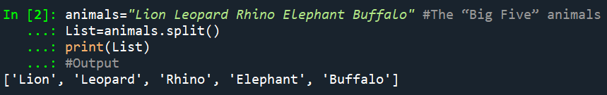
Explanation:
The code above shows how to split a string into a list using the `.split()` method. Downey (2015) notes that `.split()` method is often used to break a string into words, instead of letters. The `split()` method separates the `animals` string into a list of substrings, using spaces as the default delimiter. The resulting list displays each animal name as a separate element, allowing access to the "Big Five" animals individually.
b) Delete three words from the list
Method 1: Using the `.pop()` method
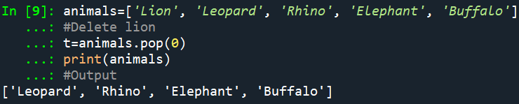
Explanation:
The code above shows how to delete an element from a list using the `.pop()` method, which usually modifies the list and returns the element that was removed (Downey, 2015). The list `animals` contains five elements: 'Lion', 'Leopard', 'Rhino', 'Elephant', and 'Buffalo'. The removed element 'Lion' is assigned to variable `t` and outputs the modified list `animals` with the remaining four elements, including 'Leopard', 'Rhino', 'Elephant', and 'Buffalo'.
Method 2: Using the del operator
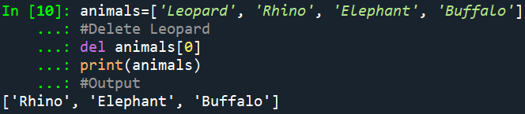
Explanation:
The above shows how to delete an element from a list using the `del` statement, which is often used when removed value is not needed (Downey, 2015). The list `animals` contains five elements: Lion, Lion, Lion, Rhino, Elephant, and Buffalo. The `del animals[0]` statement removes the 'Leopard' element at index 0 from the list. The modified list `animals` contains only the remaining four elements, and 'Leopard' is successfully removed using the `del` statement.
Method 3: Using remove statement
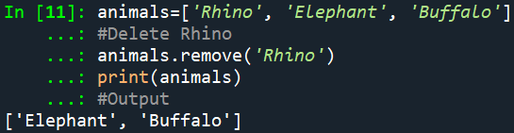
Explanation:
The code above shows how to delete an element from a list using the `remove()` method, which Downey (2015) opines that is often used to delete an element that is known. The `remove()` method is used to remove the specified element 'Rhino' from the list `animals`. The modified list `animals` contains only 'Elephant' and 'Buffalo', with 'Rhino' successfully removed.
c) Sorting the list
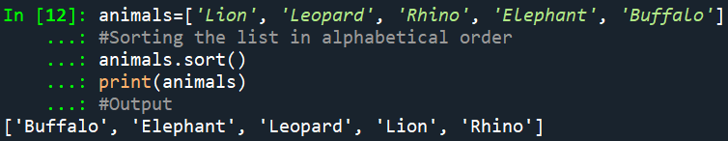
Explanation:
The code above shows how to sort a list of strings in alphabetical order using the `sort()` method. According to Downey (2015), sort arranges the elements of the list from low to high. The sorted list `animals` contains five elements: Lion, Lion, Leopard, Rhino, Elephant, and Buffalo. The `sort()` method sorts the list in alphabetical order, modifying the original list. The sorted list is displayed in the output, ensuring the original list remains unchanged.
d) Add new words to the list
Method 1: Using append() method
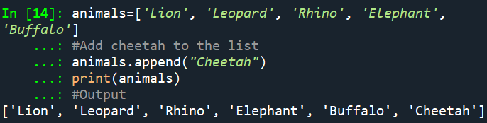
Explanation:
In the code above, the append() method is used to add the string "Cheetah" as a new element to the end of the list. According to Downey (2015), append adds a new element to the end of a list. The output of the code will be ['Lion', 'Leopard', 'Rhino', 'Elephant', 'Buffalo', 'Cheetah'], which is the finals list containing all the original animals plus the newly added "Cheetah" at the end.
Method 2: Using extend method
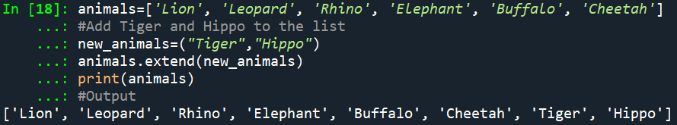
Explanation:
The code above shows how to add multiple elements to an existing list using the `extend()` method. Downey (2015) opines that extend takes a list as an argument and appends all of the elements. The list `animals` contains six original elements, including Lion, Lion, Lion, Rhino, Elephant, Buffalo, and Cheetah. To add new elements 'Tiger' and 'Hippo', a tuple `new_animals` is defined with 'Tiger' and 'Hippo'. The `extend()` method efficiently adds elements from the tuple to the end of the list, maintaining the order of the elements.
e) Turn the list of words back into a single string using join
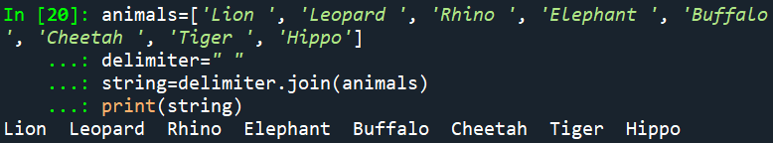
Explanation:
The code above shows how to join all the elements of the animals list into a single string, removing any delimiter between them. To achieve this, the code uses the join() method of the empty string delimiter. join takes a list of strings and concatenates the elements. Since join is a string method, it has to be invoked on the delimiter and pass the list as a parameter (Downey, 2015). The resulting string is then printed to the console with the output having a single string containing all the animal names with spaces in between them.
Part 2: Providing Examples Using Python List
- Nested list
A nested list is a list that contains other lists as its elements. Although a list can contain another list, the nested list still counts as a single element (Downey, 2015). For example, ['Cow', 4, [‘Boy’, ‘Girl'], [‘USA’, ‘Kenya’, ‘Uganda’]] is a nested list containing four elements, where some elements are themselves lists. It contains a combination of simple elements (strings and integers) and more complex elements (other lists)
- The "*" Operator
The * operator is usually used to repeat a list a given number of times (Downey, 2015). See the example below.
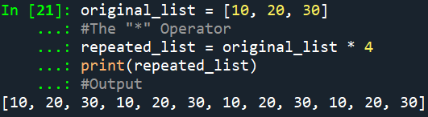
Explanation:
The code above shows a list named original_list with elements [10, 20, 30]. The "*" operator has been used to repeat the elements 4 times, as shown in the output.
- List Slices
List slices uses a range of slices to extract a portion of a list. See the example below.
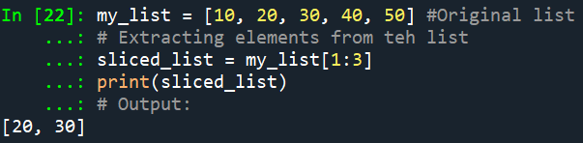
Explanation:
The code above shows how a list slicing with the range 1:3 can be used to extract elements from index 1 (inclusive) to 3 (exclusive) from a list named my_list with elements [10, 20, 30, 40, 50]. The new list named sliced_list in the output contains elements [20, 30].
- The "+=" Operator
The "+=" operator is often used to concatenate two lists together. See example below.
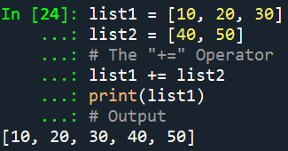
Explanation:
The code above shows how the "+=" operator can be used to concatenate list2 to list1 with elements [10, 20, 30] and [40, 50] respectively. This results in a modified list1 with elements [10, 20, 30, 40, 50], as shown in the output.
- A List Filter
A list filter provides means for developing a new list containing elements that satisfy a specific condition. See example below.
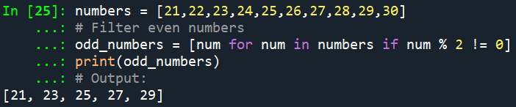
Explanation:
The code above shows use a list comprehension can be used to filter even numbers from the list. The condition num % 2!= 0 checks if the number is odd, and only the odd numbers are included in the new list named odd_numbers, which results in [21, ,23, 25, 27, 29], as shown in the output.
- A list operation that is legal but does the "wrong" thing
A common mistake is using the "+" operator with a list and an integer, expecting the integer to be added to each element in the list. See example below.
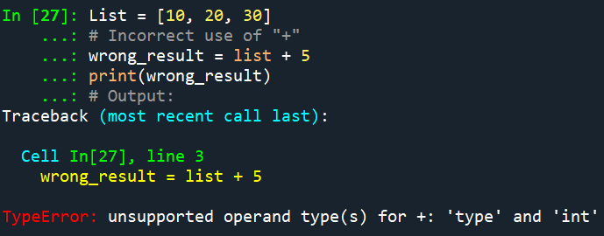
Explanation:
In the example above, the "+" operator was mistakenly used to add 5 to each element in the list, which Python could not execute the operation because the "+" operator is not defined between a list and an integer. As a result, the code raises a TypeError, indicating that a list cannot be concatenated to an integer.

Reference
Downey, A. (2015). Think Python: How to think like a computer scientist. Green Tree Press.

